About Us

Farhan Fardid:
Farhan Fardid is a student of Bangladesh University of Business & Technology (BUBT) in dept. of CSE, Intake: 32, Sec:02, ID: 15162103062.
Abu Nauam Tonmoy:
Abu Nauam Tonmoy is a student of Bangladesh University of Business & Technology (BUBT) in dept. of CSE, Intake: 32, Sec: 02, ID: 15162103190.
Abir Mahmud:
Abir Mahmud is a student of Bangladesh University of Business & Technology (BUBT) in dept. of CSE, Intake: 32, Sec: 02, ID: 15162103054.
Md. Tanvir Hossain Mitul:
Md. Tanvir Hossain Mitul is a student of Bangladesh University of Business & Technology (BUBT) in dept. of CSE, Intake: 32, Sec: 02, ID: 15162103048.

Special Contribution by – Shahanul Haque Shawon

1

Declaration

I hereby declare that the project entitled ”Restaurant Food Ordering System (RFOS) ”is submitted in partial fulfillment requirements for the course of Software Engineering in the faculty of Computer Science & Engineering of Bangladesh University of Business & Technology (BUBT) in our own work and it contains non material which has been accepted for the award to the candidates of any other degree or diploma, except where due reference is made in the text of the project to the best of our knowledge.

Signature Signature
Farhan Fardid Abu Nauam Tonmoy

Signature Signature
Abir Mahmud Md. Tanvir Hossain Mitul

2
Abstract

The concept of restaurant food ordering system, since it is an android application, I will keep everything as simple as possible. The project consists in an Android application that can be used by customer to order their food easily. This will help them to sort their meal to order. Normally, the restaurant menu is organized by categories (appetizers, soups, salads, entrees, sides and drinks) of menu items. Each menu item has a name (e.g., fried rice), price and associated recipe. A recipe for a menu item has a chef, preparation instruction associated ingredients. The ingredients are identified by their ingredient id and the quantity of the ingredient needed to prepare a particular recipe, the unit of measure and a name.
“Restaurant Food Ordering System (RFOS)" is android application to restaurant order. This system wake to provide service facility to restaurant and also to the customer. The services that are provided is food ordering by the customer through the system. First of all the customer have to install the app. In app, the food will be sorted according to the categories. Suppose any customer comes with his family or friends wants to take lunch, then firstly he has to select a budget then according to the budget he has to select which foods he wants to take as lunch. After order the food will be served according to his order. Main objective build the system this is to provide ordering to the customer. With this system, ordering will become easier and systematic to replace traditional system.

3

Acknowledgements

First and foremost, we are grateful to the Almighty Allah, the Merciful without whose patronage and blessing this project would not have been successfully completed. He gave us zeal, confidence, power of determination and courage and vanquished all the barrier that we have faced on the way. It is an auspicious moment for us as student of dept. of Computer Science & Engineering one of the prestigious academic center Bangladesh University of Business & Technology (BUBT) to express our deep feeling of gratitude to dept. and especially our honorable course teacher Md. Kamruzzman, lecturer, dept. of CSE for his wonderful guidance and inspiration and also for through review and correction of this dissertation work that could not be finalized without his astute supervision.

We pay profound regard to all of our teachers of the dept. for their very valuable direction and special attention. Our parents are very much keen and hopeful in the best performance of the dissertation we are going to submit. We wish we could fulfill their aspiration. We also pay regard to our friends in the dept. who through their interest and work are our contestant source of inspiration.

4
Table of Contents
- Introduction of the Project 7
  - Background of the Study
  - Statement of the Problem
  - Project Objectives
  - Features of the Project
  - Scope of the Project
  - Constraint of the Project
  - Project Deliveries
  - Time Schedule
  - Software and Hardware Specification

- System Requirement Study 10
  - User Characteristics
  - Hardware Requirement
  - Software Requirement
  - Functional Requirement
  - Non-Functional Requirement

- System Analysis 12
  - Study of Current System
  - Problems and Weakness of Current system
  - Feasibility
  - Development Phase
  - Methodology
  - Requirement and Analysis
  - Design
  - Coding/Implementation

- System Design 18
  - Introduction
  - Design Phase
  - Logical Design
  - Physical Design

5
- Implementation Planning and Testing 20
  - Implementation Environment
  - System Implementation
  - Testing
  - Software Testing

- Diagrams 23
  - Conceptual Diagram
  - Use Case Diagram

- Appendix 25
  - Advantages of Project
  - Features
  - Project Limitation
  - Difficulty Faced During Development
  - Scope of Future Application
  - Lessons Learned

- Conclusion and Discussion 27
  - Conclusion
  - Discussion

- References 29

6
Introduction of the Project

Introduction:
Restaurants are one of the most important sector in our modern society. Restaurant food ordering system manages a connection with customer choice and budget. This section is about understanding the background of the project study, definition of the project problem statement, its objectives, scopes, project justification, risks, project deliverables and project budget and project schedule.

Background of the Study:
Many restaurants are still operated using pen and paper methods. Once seated a waiter tends to the costumers by writing down the orders onto a piece of carbon paper to take the order. In old fashion systems, waiters have to carry pads around to take orders, always have a working pen and be sure to keep each bill organized and “synchronized” with the proper table. This “old fashion” system works but yields a large amount of receipts, wastes a lot of time and is simply out-of-date. The biggest hurdle most restaurants face is the migration from a paper-pencil system to a completely automated touch-screen system. This project computerizes restaurant operation so that all information in one screen and customer give orders by their choice within their budget.
Statement of the Problem:
Every Customer has a budget for anything to buy. Therefore, there are also a budget, when they are going to a restaurant. Every restaurant has a set menu, customer will come, then they select one set menu. However, in that menu if any food item that the customer don’t want to keep, the customer can’t avoid that item. He has to pay for the item included in the set menu. Besides there the customer has to calculate the prices in their brain so that the price does not cross the budget.
Project Objectives:
The objective of “Restaurant Food Ordering System” is to allow the customer to edit the meal

7

menu and allows the customer to maintain their budget properly.
The following are the project objectives:
- To develop a restaurant food ordering system that allows the user to choice set meal with their budget.
-To study and analyze the requirement specifications of the restaurant food ordering system.
-To produce the application requirement specification of the system.
-To produce the application design document of the system.

Features of the project:
The features of this project are:
-Customer can make a set menu with their own choice.
-customer can select the items within their budget.
-Calculation including the vat will also be shown when the customer choose their items.

Scope of the Project:
-To implement Android.
-To implement java.
-To secure the internal functions.
-To have a faster, easier calculation of the billing system including the vat.
-For doing work more accurately.

Constraint of the Project:
There are some limitations in this project. The selecting of items is done only for one person. If two persons want to have the same order, then the waiter has to take the extra one in a short note of a double order.
8

Project Deliveries:
The main deliverables of this project will be the complete system and the software engineering document that include –
-Application requirement and specification.
-Application design document.
-The software engineering document will be constructed.

Time Schedule:
Time schedule
Activity | Date | Duration(week)
Feasibility study | 23 June- 29 July | 1
Project proposal | 30June-13 July | 2
Analysis | 14July-27July | 2
Design | 28 July-10 August | 2
Development | 11 August-24 August | 2
Testing | 25August- 31 August | 1
Implementation | 1 Sept- 7 sept | 1
Report writing | 8 sept-14 sept | 1

Software and Hardware Specification:
Hardware specification:
-Laptop, Computer, Android Mobile.

Software specification:
-Microsoft windows 7 operating system.
- Android version Gingerbread 3.4 -3.4.7 or above
- Android studio.
-Net Beans for java.
9

System Requirement Study

User Characteristics:
Basically the users should have:
-A system that improves on the efficiency of information.
-A system that is easy to learn and use.
-A system that is fast in processing, ordering and calculating speed.
-A system that is flexible, safe and convenient.

Hardware Requirement:
Hardware is a set of physical components, which performs the function of applying appropriate, predefined instruction.
The following are the minimum hardware specification to run this package:
-processor: Intel -Core i3.
-RAM: 1.00 GB.
-system type: 32-bit or 64 operating system.

Software Requirement:
The following are the minimum the software specifications to run this package:
Operating system: Windows 7/Windows 10.

Functional Requirement:
- Creation of new order: This function creates a record for a new item.

10
-Deletion of record: This function is used to remove the any item from the list of the order.
-Updating in record: This function updates the information in a list of the order.
-Display of data in record: This function displays the order of the items.

Non-Functional Requirement:
-Performance: Easy tracking of order and updating can be done.
-User friendly: The system is very interactive.
-Maintainability: Backups for the data.

Facts Finding Techniques:
Objectives:
The objective of “Restaurant Food Ordering System” is to allow the customer to edit the meal menu and allows the customer to maintain their budget properly.
The following are the project objectives:
- To develop a restaurant food ordering system that allows the user to choice set meal with their budget.
-To study and analyze the requirement specifications of the restaurant food ordering system.
-To produce the application requirement specification of the system.
-To produce the application design document of the system.

Secondary Data Collection:
The data that we collect are the item list and the prices of that specific items that are available in that restaurant. So this are the main data that we are mainly operating.

11

System Analysis

Study of Current System:
Many restaurants are still operated using pen and paper methods. Once seated a waiter tends to the costumers by writing down the orders onto a piece of carbon paper to take the order. In old fashion systems, waiters have to carry pads around to take orders, always have a working pen and be sure to keep each bill organized and “synchronized” with the proper table. This “old fashion” system works but yields a large amount of receipts, wastes a lot of time and is simply out-of-date. The biggest hurdle most restaurants face is the migration from a paper-pencil system to a completely automated touch-screen system. This project computerizes restaurant operation so that all information in one screen and customer give orders by their choice within their budget. The current system for the Restaurant food ordering system deals with maintaining a physical contact with the restaurant management for filling all the details and the documentation work.

Problems and Weakness of Current system:
There are some limitations in this project. The selecting of items is done only for one person. If two persons want to have the same order, then the waiter has to take the extra one in a short note of a double order.

Feasibility:
Financial Feasibility:
Being a mobile application, this will have low cost. Since the system doesn’t consist of any multimedia data transfer, bandwidth required for the operation of this application is very low.
The system will follow the freeware software standards. No cost will be charged from the potential customers. Bug fixes and maintaining tasks will have an associated cost. At the initial stage, the potential market space will be the local universities and higher level of restaurant. Beside the associated cost, there will be many benefits for the customers. Especially the extra effort as if customer can easily chose

12

his own food item, he also can check the price of the total, and for this he doesn't need to pay extra money. From these it is clear that the project OES is financially feasible.

Technical Feasibility:
Project is completely an android mobile-based application. The main technologies and tools that are associated with this system are:

*NetBeans.
* Pencil (Diagram drawing tools).
* Android Studio
Each of the technologies are available and the technical skills required are manageable. Time limitations of the product development and the ease of implementing using these technologies are synchronized. From these it’s clear that the project OES is technically feasible.

Resource and Time Feasibility:
Resource feasibility
Resources that are required for the Restaurant Food Ordering System project includes,
Programming device (Laptop)
Programming tools (freely available)
Programming individuals
Android Studio
Data Server.
So it is clear that the project OES has the required resource feasibility.

Risk Feasibility:
In this project, there are some risk feasibility available:

- Estimated size of the product in line of codes:
As the system doesn’t contain any multimedia aspect, the file sizes and the complete
project size will not exceed 10 MB.

- Development Environment Risk: Android Studio will be used as the main project management tool.
Development environment risks
Is a software project management tool available?
Android Studio will be used as the main project management tool.
Are tools for analysis and design available?

- Technical issue risks: Failure of the used technique can eventually arise and can affect the outcome.

13
Are software configuration management tools available?
Configuration management will be done using GIT that is freely available?
Technical issue risks are specific conventions for code documentation defined and
used?
Software code will be freely available and the code documentation will be provided.
Do you use a specific method for test case design?
JUNIT will be use as the main testing tool that
Automates the testing process.
Are configuration management software tools used to control and track change activity
Throughout the software process?

- Legal costing issue risk: Only the maintenance cost will be charged from potential customers. Since this new system eliminates the effort to make statistical distributions, it will have a great impact in a restaurant system.

Development Phase:
The SDLC:
It is comprised of the stages that the developer will use when developing the system. It is a sequential model hence, the name system development life cycle. The developer has to finish with one stage before going to the next one. It comprises of the feasibly study, analysis phase, design phase, coding phase, testing phase, implementation phase and finally the maintenance phase. It is a simple model and easy to use and understand. The deliverables from each phase are voluminous and are presented to the sponsor for approval as the project moves from phase to phase. Once the phase is approved by the sponsor, it ends and the next phase begins.

Methodology:
We use the waterfall model for this project-

- Requirement Gathering and analysis − All possible requirements of the system to be developed are captured in this phase and documented in a requirement specification document.
- System Design –The requirement specifications from first phase are studied in this phase and the system design is prepared. This system design helps in specifying hardware
14
and system requirements and helps in defining the overall system architecture.
- Implementation –With inputs from the system design, the system is first developed in small programs called units, which are integrated in the next phase. Each unit is developed and tested for its functionality, which is referred to as Unit Testing.
- Integration and Testing − All the units developed in the implementation phase are integrated into a system after testing of each unit. Post integration the entire system is tested for any faults and failures.
- Deployment of system − Once the functional and non-functional testing is done; the product is deployed in the customer environment or released into the market.
- Maintenance − There are some issues which come up in the client environment. To fix those issues, patches are released. Also to enhance the product some better versions are released. Maintenance is done to deliver these changes in the customer environment.

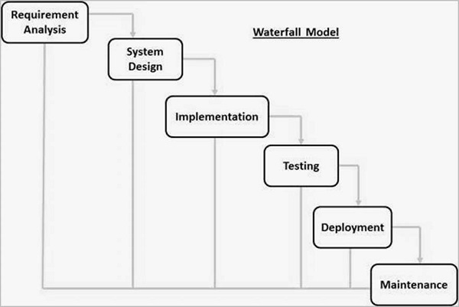
15
Requirement and analysis:

At this stage we will gather information about what the customer needs and define the problems the system is expected to solve. We will also gather requirement such as software like the programming language to use and hardware needed.

Design:
At this stage, we will make an overall design of the system architecture and physical design which includes user interface. It is at this stage that we will identify any faults before moving onto the next stage. The output of this stage is the design specification which is used in the next stage of implementation.

Coding/Implementation:
At this stage, we will begin coding as per the design specification. The output is one or more product components built according to a pre-defined coding standard and debugged, tested and integrated to satisfy the system architecture requirement.

Testing:
At this stage, I will ensure both individual and integrated which are methodically verified to ensure they are error free and satisfy customer requirement. I will involve individual code module, system testing of the integrated product and acceptance testing conducted by or on behalf of customer. I will ensure bugs found are corrected before moving to the next stage, I will also prepare review and publish product documentation at this stage.

Installation:
It is done once the product has been tested and certified as fit for use. The system is prepared for use at customer site.

16

Maintenance:
This stage occurs after installation. It involves modification on the system to improve performance. Such changes are use initiated or as a result of bug, being discovered which were initially not known. These modifications are recorded for documentation and system update.

17
System Design

Introduction:
Design is the first step of the development phase of any engineered product or System. It is the most creative process of any product; a good design is the key of the effective system. In this System Design team we will talk about the process of applying various techniques and principles for the purpose of defining a process or a system in sufficient detail to permit its physical realization. In this phase we will discuss about all the Design process.

Design Phase:
This is an Android base application system and in this phase we will show how a user can use this application and how the admin can change the system and how to operate the whole system or the way of creating this system. It is only the administrator who can change the menu or make change when necessary. But the user can only select his/her own choice food but they can't change the system or the food item. The food list will already be set on our app and customer just select the items.

Logical Design:
The Logical Flow of a system define the boundaries of a system. It includes the following steps:
1. Reviews the current physical system- data flows, file content, Volumes etc.
2. Prepares output specifications -Determines the format, content and frequency of reports.
3. Prepares input specifications- format, content and most of the input functions.
4. Prepares edit, security and control specifications.
5. Specifies the implementations plan.
6. Prepares a logical design walk through of the information flow, output and input.
7. Controls and implementation plan.
18
Physical Design:
In this section we will show how the system is made and it's follows this instructions.
# Design the physical system.
# Specifies input and output media.
#Plan system implementation.
#Prepare a conversation schedule and target date.
#Determine training procedures, course and timetable.
#Devise a test and implementation plan and specify any hew hardware/software.
#Update benefits, costs, conversion data and system constraints.

19
Implementation Planning and Testing

Implementation Environment:
Restaurants are one of the most important sector in our modern society. Restaurant food ordering system manages a connection with customer choice and budget. This section is about understanding the background of the project study, definition of the project problem statement, its objectives, scopes, project justification, risks, project deliverables and project budget and project schedule.
It is the phase where visions and plans become reality. This is the logical conclusion, after evaluating, deciding, visioning, planning, applying for funds and finding the financial resources of a project. Technical implementation is one part of executing a project.

System Implementation:
Systems implementation is the process of-
#defining how the information system should be built
#ensuring that the information system is operational and used.
#ensuring that the information system meets quality standard.
If all this process is successfully installed then we can say that the required system is perfectly implemented.
Several activities included also:
*End user training.
*End user education.
*Training on the application software.
*Post implementation Review.

- End user training:
The successful implementation of the new system will purely upon the involvement of

20
the officers working in that department. Then they will be imparted the necessary training on the new technology.
- End user education:
The education of the end user start after the implementation and testing is over.
When the system is implemented the system is found to be more difficult to understand and complex. More effort is put to educate the end user to make them aware of the system, giving them lectures about the new system implementation and providing them necessary documents and materials about how the system can do.

- Training on the application software:
After providing the necessary basic training on the system awareness, the users will have to train upon the new system such as the screen flows and screen design type to help on the screen, type of errors while entering the record, the corresponding validation check at each entry and the way to correct the data. It should then cover the implementation information needed by the specific user or group to use the system.

- Post implementation Review:
The development includes a planning of a method to know the states of the pos implementation process, for that regular meeting will be arranged by the concerned officers about the implementation problem and success.

Testing:
Software testing has dual function.it is used to identify the defects in program and it is used to help judge whether or not program is usable in practice. Thus software testing is used for validation and verification, which ensure that software conforms to its specification and meets need of the software customer.
The alfa testing, which usually comes in after the basic design of the program has been completed. The project will look over the program and give suggestions and ideas to improve the implementation. They also give ideas to get rid of around any major problems. All the units developed in the implementation phase are integrated into a system after testing of each unit. Post integration the entire system is tested for any faults and failures.
Software testing is an investigation conducted to provide stakeholders with information about the quality of the software product or service under test. Software testing can also provide an objective, independent view of the software to allow the business to appreciate and understand the risks of software implementation. Test techniques include the process of executing a program or application with the intent of finding software bugs, errors or other problems and verifying that the software product is fit for use.
21

Software Testing:
I will ensure both individual and integrated which are methodically verified to ensure they are error free and satisfy customer requirement. I will involve individual code module, system testing of the integrated product and acceptance testing conducted by or on behalf of customer. I will ensure bugs found are corrected before moving to the next stage, I will also prepare review and publish product documentation at this stage. Software testing is an investigation conducted to provide stakeholders with information about the quality of the software product or service under test. Software testing can also provide an objective, independent view of the software to allow the business to appreciate and understand the risks of software implementation. Test techniques include the process of executing a program or application with the intent of finding software bugs, errors or other problems and verifying that the software product is fit for use.
All the units developed in the implementation phase are integrated into a system after testing of each unit. Post integration the entire system is tested for any faults and failures. Software testing involves the execution of a software component or system component to evaluate one or more properties of interest. In general, these properties indicate the extent to which the component or system under test Software testing can provide objective, independent information about the quality of software and risk of its failure to users or sponsors.

22

Diagrams

Conceptual Diagram:
Conceptual diagram is the very first phase of design in which drawings or solid models are the dominant tools and products.

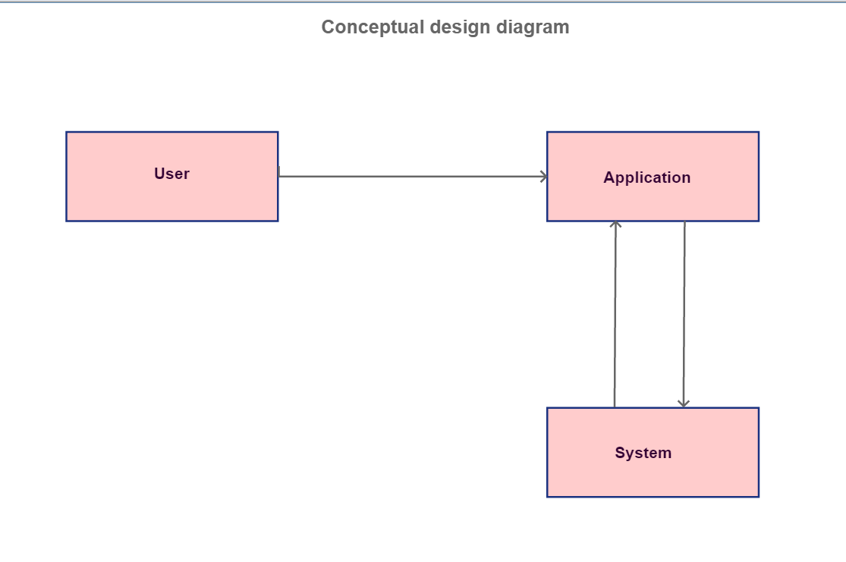
23
Use Case Diagram:

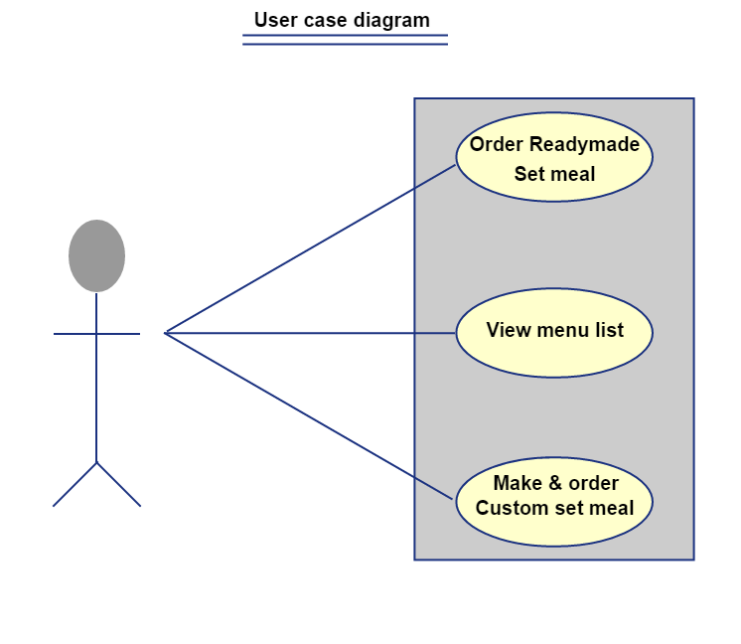

24

Appendix

Advantages of Project:
Every Customer has a budget for anything to buy. So there are also a budget, when they are going to a restaurant. Every restaurant has a set menu, customer will come, and then they select one set menu. However, in that menu if any food item that the customer do not want to keep, the customer cannot avoid that item. He has to pay for the item included in the set menu. Besides there the customer has to calculate the prices in their brain so that the price does not cross the budget.
Our project is to make restaurant food ordering system much more easy and user friendly to restaurant owner and the customer. When a customer use this application he/she will feel much more comfort to order his need and this application also saves the time so that employee can do some other productive task. And this is just a mobile application and it is so much easy to install so that user won't suffer any problem.

Features:
The features of this project are following:
#Customer can make a set menu by their choice.
#Customer can select the item by their budget.
#Application will calculate all food item price include vat and instantly show to the customers.
#View the ordered item list all at the same time.
#prices are included with the vat so the customers don’t need to tensed about the total costing with the vat extra charge.

Project Limitation:
There are some limitations in this project. The selecting of items is done only for one person. If two persons want to have the same order then the waiter has to take the extra one in a short note
25
of a double order. When a customer order a food item he/she can't see any photo of the food in the application, then he need to ask the waiter about the item. Then the waiter will tell him the details about the food.

Difficulty Faced During Development:
Our development team faced at first the funding difficulties during developing the application. The application did not run at the first attempt. But after working few days more we overcome the problem and run the application successfully.

Scope of Future Application:
Scope of further development of the application:
# We will add credit or bikash payment options.
# We will add photo of every food item.

Lessons Learned:
The things we learned to developing a project needs a team work and most importantly learned to complete a project within time and limited resources.

26

Conclusion and Discussion

Conclusion:
The main purpose is to make restaurant food ordering system much more easy and fast and make all the restaurant system much more user friendly so that customer can get all the thing he needs and our team can say we tried our best it would be the best application and users will love to use this application.

Discussion:
Restaurants are one of the most important sector in our modern society. Restaurant food ordering system manages a connection with customer choice and budget. This application is easy to use and any restaurant can use this application and get benefited and the customer would love to use it.

Self Analysis of Project Viabilities:
Restaurant Food ordering system is a very efficient system for the restaurant food order and billing system. Most of all the time can be easily save with this system. This can be used by any restaurant.
It was quite a challenging one to develop this project. If any changes in this system are to be made then they can be done easily.

Open End Question:
- What are the important things you know about the system?
- What is your opinion about the system?
- How was the system service?
- How much satisfied or dissatisfied are you with this process?

27
- How do you know about our project?
- Which kind of information would you likely to be in there?
- What would you most want to change about our system?
- Which things you like the best about our hospital management?

Close-End Question:
- Is our system help you to order your food easily?
- Is this was efficient to you about the system process?
- Are you satisfy about our work?
- Are you consulting to implementing this system in your own restaurant?
- Do you think you would use this?
- Have you ever use this before?
- Is this easy to use?
- Are you satisfied with our work?
- Do you like

28

References

- Website:
- Google
- Wikipedia
- Tutorials point
- Slide share
- W3computing
- Book:
- System Analysis &Design - By Kendall & Kendall

The End

29

